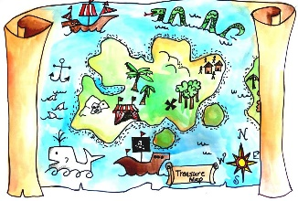
Caza de tesoro en casa
Year 6 Actividad de Transición – español

- Watch this YouTube video to learn the colours in Spanish: https://www.youtube.com/watch?v=zpLQSdu4V94

- Find an object in your house which matches the description and take a photo. Use www.wordreference.com to find out the meaning of the key words in the description (in bold), but only if you get really stuck!

- Make a collage of all your photos. We would love it if you could also link this to the “Thank You, NHS” campaign which has been running over the last few weeks. You could add “Gracias, NHS” to your collage if you would like to.

- Upload your final entry to our Padlet: https://padlet.com/kwoodman4/3sst1ixgy98r4pdg so we can all see how wonderful and creative you are!
BE CREATIVE!

¡Mucha suerte!
- Busca algo rojo.

- Busca algo naranja.

- Busca algo amarillo.

- Busca algo verde.

- Busca algo azul.

- Busca algo índigo.

- Busca algo violeta.

