Student Arbor App Instructions
The school uses an app for homework. In addition to the app, a website may also be used to access basic information. Both the app and the website use the same logon details.
Before a student can use the Arbor app or website for the first time, the student must have access to their school email inbox. If you are not in school, or using a mobile phone, school email inboxes may be opened by navigating to the website:
https://outlook.office.com/
At all times in this document, the school email address is the student “name” used to logon school computers, followed by @newman.cumbria.sch.uk The password refers to the school logon “password”. For example, if you log onto the school system using bsmith23 then your email will be bsmith23@newman.cumbria.sch.uk

Logging onto Arbor App/Website for the first time
Since the username and password details are the same for the app and website, this process needs only be performed once. Initially, Arbor WILL NOT WORK for students, the student must set the password themselves. A welcome email has been sent to students with a link to reset their password, however it is also possible to follow these steps to set the initial password:
- Use a browser to navigate to the following website:
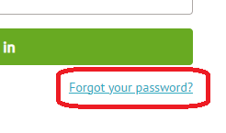
https://login.arbor.sch
- Click the “Forgot your Password?” link
- Type your school email address (the @newman.cumbria.sch.uk address) and click Reset Password.
- Log onto your school email inbox. If you are not in school or using your mobile phone, you can open your school email by navigating to the website https://outlook.office.com/ using your school email address and password.
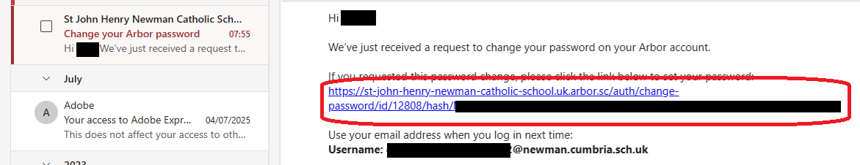
- An email will arrive from Arbor, with a link to reset your password. Click the link.

- When asked to change your password, choose the SAME password that you use to log onto school computers, and school email.

Which App should I be using?
Using the google play store or Apple store, there are several Arbor apps available. In the google play store, the app used by Students is named:
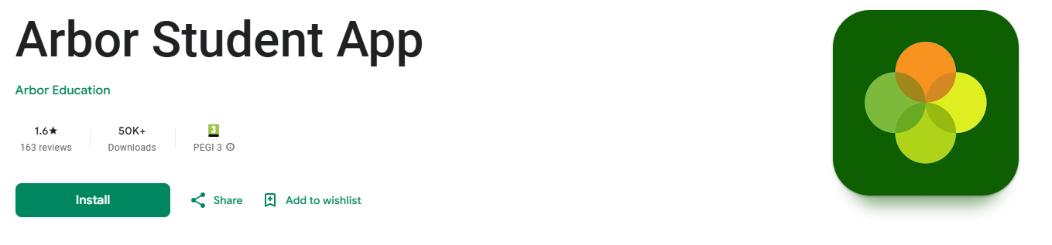
It is important to download and install the Arbor Student App created by Arbor Education.
For the Apple Store, the app is named:
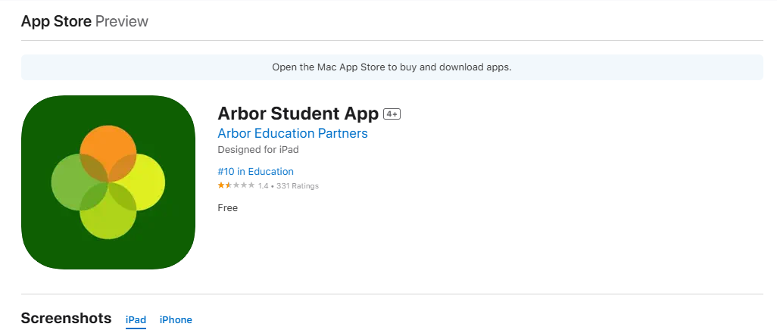
It is important to download and install the Arbor Student App created by Arbor Education Partners.
On shared devices, it is entirely possible that you already have the parent Arbor app installed. The two apps are separate and will use separate login details.

How can I log onto the Arbor website without the app?
To log onto the Arbor website without using the app, use a browser and navigate to:
https://login.arbor.sch

